**ASSIGNMENT-3**

**Name: SRIDHAR.T**

**Reg no: 713519CEIT036**

**College Name: SNS COLLEGE OF ENGINEERING**

***PROGRAM FOR TRAFFIC LIGHT***

**Python Code:**

void setup() {

  Serial1.begin(9600);

  pinMode(21, OUTPUT);

  pinMode(11, OUTPUT);

  pinMode(19, OUTPUT);

}

void loop() {

  digitalWrite(21, HIGH);

  delay(3000);

  digitalWrite(21, LOW);

  digitalWrite(11, HIGH);

  delay(1000);

  digitalWrite(11, LOW);

  digitalWrite(19, HIGH);

  delay(3000);

  digitalWrite(19, LOW);

}

**OUTPUT:**

**Traffic Lights For Raspberry Pi**

**Blinking Red Light:** 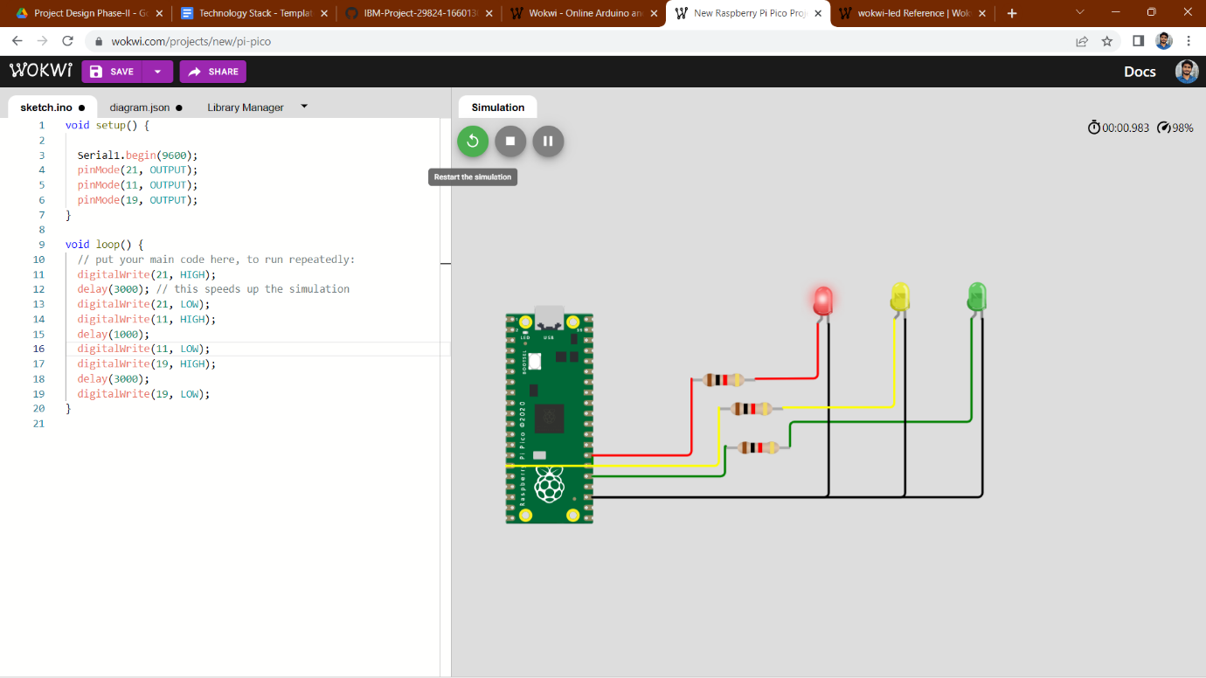

**Blinking Yellow Light:** 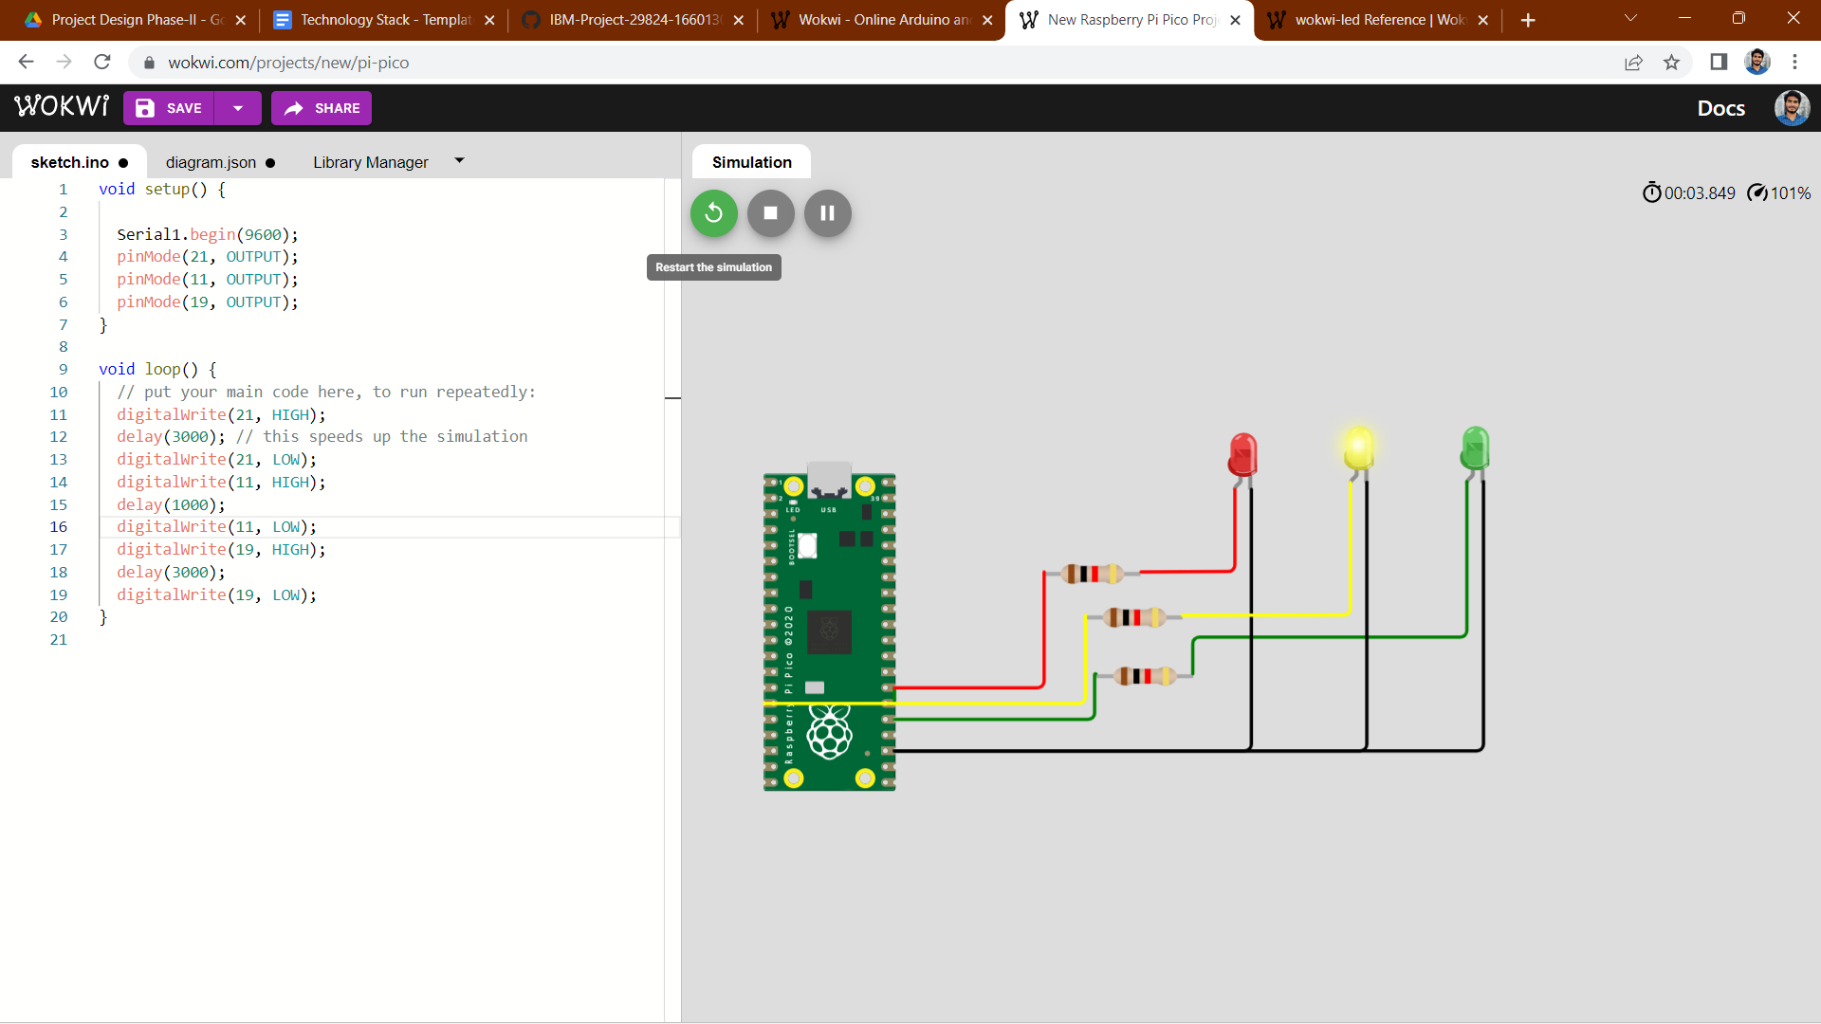

**Blinking Green Light:** 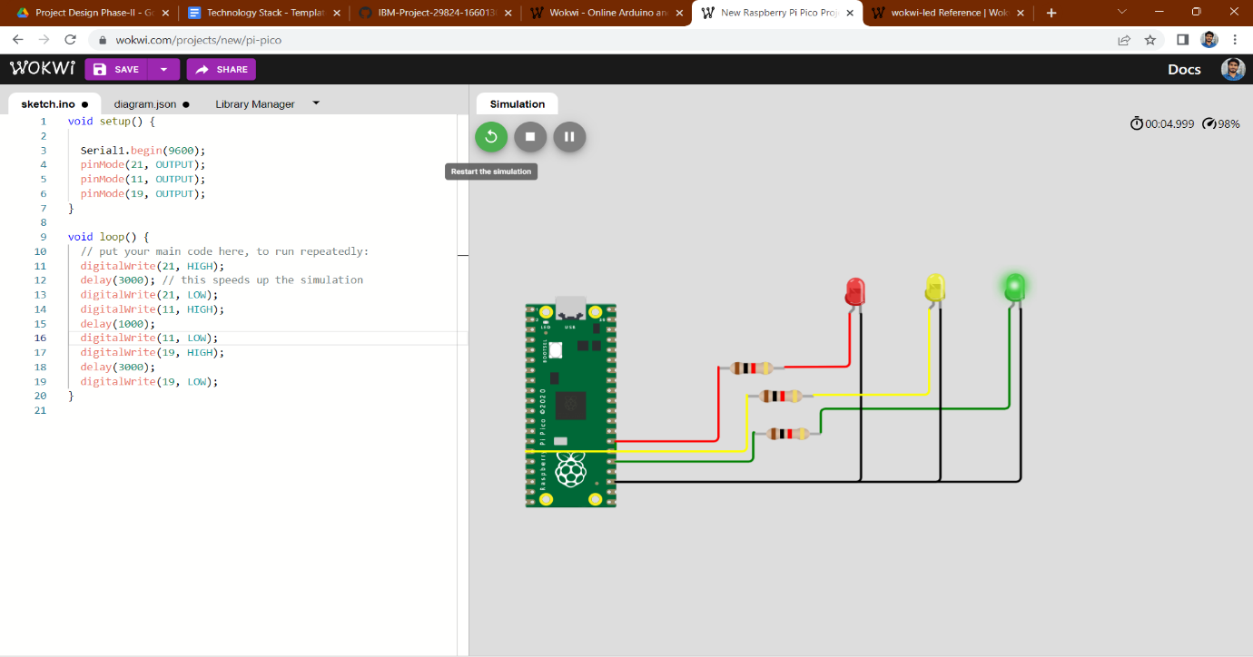

**BLINKING LED:**

**PROGRAM FOR BLINKING LED:**

**Python code:**

void setup() {

  Serial1.begin(9600);

   pinMode(22, OUTPUT);

}

void loop() {

  digitalWrite(22, HIGH);

**Serial**.println("LED ON");

  delay(1000);

  digitalWrite(22, LOW);

**Serial**.println("LED OFF");

  delay(1000);

}

**Output:**

**Blinking LED For Raspberry pi:**

